**Code for Get**

<!doctype html>

<html lang="en">

<head>

<meta charset="utf-8">

<meta name="viewport" content="width=device-width, initial-scale=1">

<title>Registration Form</title>

<link href="https://cdn.jsdelivr.net/npm/bootstrap@5.3.3/dist/css/bootstrap.min.css" rel="stylesheet"

integrity="sha384-QWTKZyjpPEjISv5WaRU9OFeRpok6YctnYmDr5pNlyT2bRjXh0JMhjY6hW+ALEwIH" crossorigin="anonymous">

<style>

body {

font-family: Arial, sans-serif;

background-color: #f8f9fa;

padding: 20px;

}

h1 {

text-align: center;

margin-bottom: 30px;

}

form {

max-width: 400px;

margin: 0 auto;

background-color: #fff;

padding: 20px;

border-radius: 10px;

box-shadow: 0px 0px 10px 0px rgba(0, 0, 0, 0.1);

animation: fadeInDown 1s ease;

}

@keyframes fadeInDown {

0% {

opacity: 0;

transform: translateY(-50px);

}

100% {

opacity: 1;

transform: translateY(0);

}

}

label {

font-weight: bold;

}

input[type="text"],

input[type="email"] {

width: 100%;

padding: 10px;

margin-bottom: 20px;

border: 1px solid #ccc;

border-radius: 5px;

box-sizing: border-box;

transition: border-color 0.3s ease;

}

input[type="submit"] {

width: 100%;

padding: 10px;

background-color: #007bff;

color: #fff;

border: none;

border-radius: 5px;

cursor: pointer;

transition: background-color 0.3s ease, transform 0.3s ease;

}

input[type="submit"]:hover {

background-color: #0056b3;

}

input[type="submit"]:focus {

outline: none;

box-shadow: 0 0 0 3px rgba(0, 123, 255, 0.5);

}

input[type="submit"]:active {

background-color: #0056b3;

transform: translateY(1px);

}

input[type="text"]:hover,

input[type="email"]:hover {

border-color: #007bff;

}

input[type="text"]:focus,

input[type="email"]:focus {

border-color: #007bff;

box-shadow: 0 0 0 3px rgba(0, 123, 255, 0.1);

}

</style>

</head>

<body>

<h1>Registration Form - GET Method</h1>

<form action="/asprojgetpost/getmain1.php" method="get">

<label for="name">Name:</label>

<input type="text" id="name" name="name" required><br>

<label for="email">Email:</label>

<input type="email" id="email" name="email" required><br>

<input type="submit" value="Register">

</form>

<script src="https://cdn.jsdelivr.net/npm/bootstrap@5.3.3/dist/js/bootstrap.bundle.min.js"

integrity="sha384-YvpcrYf0tY3lHB60NNkmXc5s9fDVZLESaAA55NDzOxhy9GkcIdslK1eN7N6jIeHz"

crossorigin="anonymous"></script>

</body>

</html>

<!DOCTYPE html>

<html>

<head>

<title>Registration Form - GET Method</title>

<style>

body {

font-family: Arial, sans-serif;

margin: 20px;

padding: 20px;

}

.container {

max-width: 800px;

margin: 0 auto;

background-color: #f9f9f9;

padding: 20px;

border-radius: 8px;

box-shadow: 0 0 10px rgba(0, 0, 0, 0.1);

}

h1 {

color: #333;

}

p {

color: #666;

line-height: 1.6;

}

</style>

</head>

<body>

<div class="container">

<h1>Registration Form - GET Method</h1>

<?php

if ($_SERVER['REQUEST_METHOD'] == 'GET') {

$name = $_GET['name'];

$email = $_GET['email'];

echo '<p>The GET method is one of the two primary HTTP request methods used in web development, alongside POST. It is primarily utilized for retrieving data from a server or requesting a resource specified by a URL. When a request is made using the GET method, the data is appended to the URL as query parameters.</p>';

echo '<p>Here are some key characteristics of the GET method:</p>';

echo '<ul>';

echo '<li><strong>Data Submission:</strong> The data submitted using the GET method is appended to the URL as key-value pairs. For example, in a typical URL, you might see something like <code>example.com/page?name=John&age=30</code>, where <code>name</code> and <code>age</code> are the parameters being passed.</li>';

echo '<li><strong>Visibility:</strong> Since the data is appended to the URL, it becomes visible to users in the address bar of the browser. While this makes it easy to understand what data is being transmitted, it also poses a security risk for sensitive information.</li>';

echo '<li><strong>Idempotent:</strong> GET requests are considered idempotent, meaning that multiple identical requests will produce the same result. They should not have any side effects on the server, such as modifying data.</li>';

echo '<li><strong>Caching:</strong> GET requests can be cached by browsers and proxies, which can lead to performance improvements, particularly for frequently accessed resources. However, caching can sometimes lead to outdated or stale data being displayed.</li>';

echo '<li><strong>Limitations:</strong> While GET requests are suitable for retrieving data, they have limitations in terms of the amount of data that can be sent. Data is appended to the URL, and there are practical limits on URL length imposed by browsers and servers. This can restrict the use of GET for transmitting large amounts of data.</li>';

echo '</ul>';

}

?>

</div>

</body>

</html>

**Output of Get**







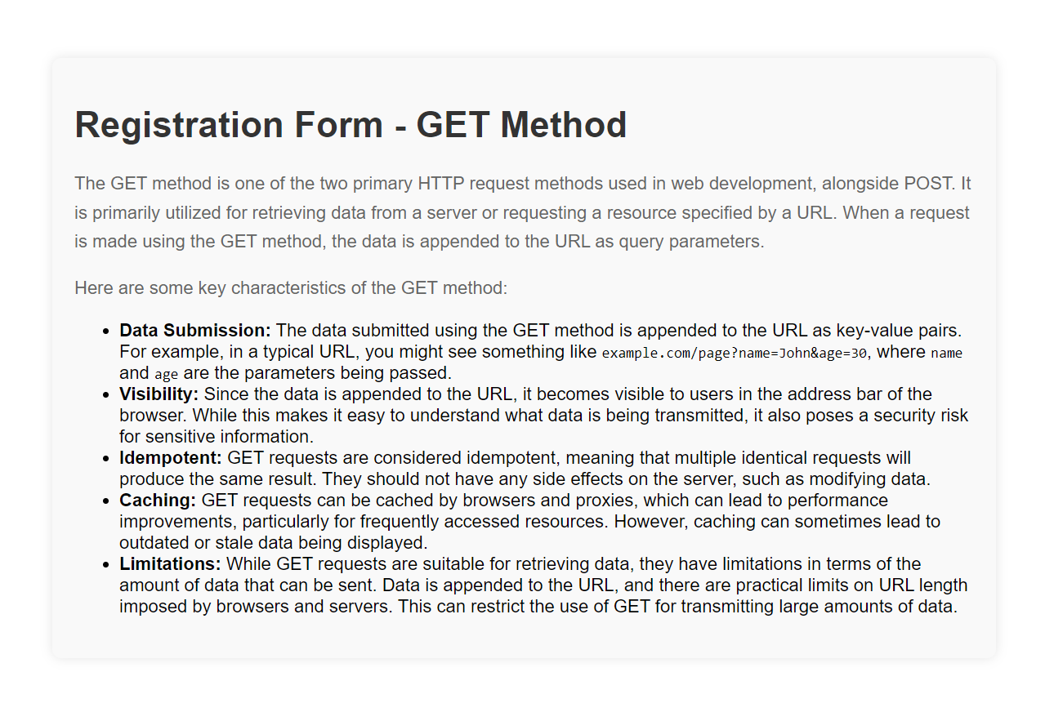

**Code for Post**

<!doctype html>

<html lang="en">

<head>

<meta charset="utf-8">

<meta name="viewport" content="width=device-width, initial-scale=1">

<title>Registration Form</title>

<link href="https://cdn.jsdelivr.net/npm/bootstrap@5.3.3/dist/css/bootstrap.min.css" rel="stylesheet"

integrity="sha384-QWTKZyjpPEjISv5WaRU9OFeRpok6YctnYmDr5pNlyT2bRjXh0JMhjY6hW+ALEwIH" crossorigin="anonymous">

<style>

body {

font-family: Arial, sans-serif;

background-color: #f8f9fa;

padding: 20px;

}

h1 {

text-align: center;

margin-bottom: 30px;

}

form {

max-width: 400px;

margin: 0 auto;

background-color: #fff;

padding: 20px;

border-radius: 10px;

box-shadow: 0px 0px 10px 0px rgba(0, 0, 0, 0.1);

animation: fadeInDown 1s ease;

}

@keyframes fadeInDown {

0% {

opacity: 0;

transform: translateY(-50px);

}

100% {

opacity: 1;

transform: translateY(0);

}

}

label {

font-weight: bold;

}

input[type="text"],

input[type="email"] {

width: 100%;

padding: 10px;

margin-bottom: 20px;

border: 1px solid #ccc;

border-radius: 5px;

box-sizing: border-box;

transition: border-color 0.3s ease;

}

input[type="submit"] {

width: 100%;

padding: 10px;

background-color: #007bff;

color: #fff;

border: none;

border-radius: 5px;

cursor: pointer;

transition: background-color 0.3s ease, transform 0.3s ease;

}

input[type="submit"]:hover {

background-color: #0056b3;

}

input[type="submit"]:focus {

outline: none;

box-shadow: 0 0 0 3px rgba(0, 123, 255, 0.5);

}

input[type="submit"]:active {

background-color: #0056b3;

transform: translateY(1px);

}

input[type="text"]:hover,

input[type="email"]:hover {

border-color: #007bff;

}

input[type="text"]:focus,

input[type="email"]:focus {

border-color: #007bff;

box-shadow: 0 0 0 3px rgba(0, 123, 255, 0.1);

}

</style>

</head>

<body>

<h1>Registration Form - POST Method</h1>

<form action="/asprojgetpost/postmain1.php" method="post">

<label for="name">Name:</label>

<input type="text" id="name" name="name" required><br>

<label for="email">Email:</label>

<input type="email" id="email" name="email" required><br>

<input type="submit" value="Register">

</form>

<script src="https://cdn.jsdelivr.net/npm/bootstrap@5.3.3/dist/js/bootstrap.bundle.min.js"

integrity="sha384-YvpcrYf0tY3lHB60NNkmXc5s9fDVZLESaAA55NDzOxhy9GkcIdslK1eN7N6jIeHz"

crossorigin="anonymous"></script>

</body>

</html>

<!DOCTYPE html>

<html>

<head>

<title>Registration Form - POST Method</title>

<style>

body {

font-family: Arial, sans-serif;

margin: 20px;

padding: 20px;

}

.container {

max-width: 800px;

margin: 0 auto;

background-color: #f9f9f9;

padding: 20px;

border-radius: 8px;

box-shadow: 0 0 10px rgba(0, 0, 0, 0.1);

}

h1 {

color: #333;

}

p {

color: #666;

line-height: 1.6;

}

</style>

</head>

<body>

<div class="container">

<h1>Registration Form - POST Method</h1>

<?php

if ($_SERVER['REQUEST_METHOD'] == 'POST') {

$name = $_POST['name'];

$email = $_POST['email'];

echo '<p>The POST method is one of the two primary HTTP request methods used in web development, alongside GET. It is commonly utilized for submitting data to a server, particularly when the data contains sensitive information or when the data size exceeds the limitations of the GET method.</p>';

echo '<p>Here are some key characteristics of the POST method:</p>';

echo '<ul>';

echo '<li><strong>Data Submission:</strong> Unlike the GET method, data submitted using the POST method is transmitted in the request body, rather than being appended to the URL. This makes it suitable for handling large amounts of data and sensitive information, as the data is not visible in the address bar.</li>';

echo '<li><strong>Security:</strong> POST requests are generally considered more secure than GET requests for transmitting sensitive information, as the data is not visible in the URL and is encrypted when sent over HTTPS.</li>';

echo '<li><strong>Idempotent:</strong> POST requests are not inherently idempotent, meaning that multiple identical requests may produce different results, especially if the request modifies data on the server. However, it is common practice to design POST requests to be idempotent by ensuring that they have the same effect regardless of how many times they are submitted.</li>';

echo '<li><strong>Complexity:</strong> Implementing POST requests may require additional effort compared to GET requests, as it involves handling data submitted through forms or API calls and processing it on the server-side. However, this additional complexity provides greater flexibility and security.</li>';

echo '<li><strong>Usage:</strong> POST requests are commonly used for operations that modify data on the server, such as submitting forms, uploading files, or performing database transactions.</li>';

echo '</ul>';

}

?>

</div>

</body>

</html>

**Output of Post**







